MARK YOUR CALENDAR

OJA SPRING SEMINAR APRIL 3, 2022
OKLAHOMA CITY

Sunday Seminar featuring special guest speaker Benjamin Smithee Topic: Brand Impact from the Sales Floor

Brand IMPACT from the Sales Floor

Brand equity is the only thing that separates your business from the sea of sameness. But what are the real components of a successful brand? How can it bring value on the sales floor of a retail jeweler? How do marketing, advertising, branding, and sales all work together in symphony to
increase sales? Ben Smithee and his team at TSG are the leaders in digital marketing and
advertising for the jewelry industry. Ben’s presentation will teach you about Brand IMPACT, and how it can help you build value, increase your traffic, and ultimately support a new growth in sales.

Ben Smithee is CEO of The Smithee Group (TSG), a
Digital Growth Agency that offers a full suite of digital marketing and media solutions that leverage their
extensive expertise in research and analytics – areas where many agencies today rely on assumptions and guesswork. TSG’s mission is to empower
entrepreneurs and businesses to dream bigger and aachieve multi-generational integrity.

Ben’s experience ranges from global companies,
including McDonald's, General Mills, Coca-Cola, EA Games, Cox Automotive and Signet, to startups and
scale-ups seeking to utilize digital technology and see true performance results.
Ben currently fulfills a role of advisor to the "Black in Jewelry Coalition," is the Executive Vice President of the Board of Trustees for Big Brothers/Big Sisters of NYC, and serves on the Board of Directors for Gem Legacy, which supports the artisanal mining communities in East Africa with education, training, childcare, healthcare, and business opportunities. When not in the business and non-profit worlds, you can find Ben on the track, racing cars; on a mountainside, snowboarding; or on the links, playing golf.

Don’t miss this exciting session. See Registration Information in this Newsletter.

Sponsored by AGS

THE OKLAHOMA JEWELER
The Newsletter of the Oklahoma Jewelers Association

Volume 2 February 2022 Issue 32

Message From the President

In reading the OJA 100th Anniversary Book recently, I was reminded of our history of always seeing the importance of “coming together” to educated ourselves in ways to better run our businesses and make them more profitable. Below are some excerpts from the book.

Key cities were established immediately after the land run of 1889, often with a jeweler in each city. By 1890, these jewelers were registered in the directory of “The Lands Opened by the Run of April 22, 1889:” C.W. White, Guthrie; W.P Norman, Norman; H.T. Ritche, El Reno; Bert Hilton, Stillwater; W.R. Snyder, Purcell; George Deihl, Mulhall, and Samuel Allen, Kingfisher. Although the Oklahoma Retail Jewelers Association would not be formed until 17 years later, it was these and other like them who laid the foundation for the jewelry industry in Oklahoma. And our organization that formed just a few years later.

Realizing a need to come together for the good of all, many Oklahoma jewelers met in 1906 and organized the Oklahoma Retail Jewelers Association, holding their first convention in 1907. By 1909 there were approximately 100 members in the ORJA.

From the very beginning, the purpose of the ORJA was for members to help one another in their businesses, protect and improve the industry, and protect the customer from unscrupulous advantage. Speakers were brought in from Kansas City, St. Louis, Chicago and New York; and in addition to the “national speakers,” a great deal of time was spent with the ORJA members discussing the important matters of the day with one another.

The “purpose” that our founders established 116 years ago of “coming together” is as important today and it was then. Many of the issues we currently face are the very same as those that challenged our founders. And with organized and specialized crime, the Internet, and competition from previously unconceived sources, we face challenges today that our founders never imagined.

Today, I believe that it is more important than ever that we keep up to date by learning from knowledgeable and respected national speakers, as well as from one another. If you feel “social-media challenged,” chances are there is a fellow jeweler who can be your lead. If more product knowledge is your need – the OJA is a place you can find it.

On April 3, 2022, you have an excellent opportunity to join your fellow jewelers for a special time of learning and fellowship -- a wonderful opportunity to hear and learn from Benjamin Smithee, a well known and high-in-demand speaker, at a convenient time and a nominal cost. Pull out or copy the Registration Form in this newsletter and send it in today.

I hope to see you in OKC in April, and if it’s your first time, it will be my special pleasure to get to know you better!

Gen Lisle
Gen
President, Oklahoma Jewelers Association

JEWELERS SECURITY ALLIANCE

The Jewelry Industry’s First Line for Crime Defense

JSA President John Kennedy speaks to crime trends following the release of the organization’s annual report.

New York -- The Jewelers’ Security Alliance recently published its annual crime report for 2020, which was delayed because of COVID-19 but still provides insight about crime trends in the jewelry industry.
President John J. Kennedy said 2020 was a year in which there were more crimes against the jewelry industry, but dollar losses shrank. Also, while there were more opportunists committing low-dollar crimes , there were fewer smash-and-grabs and safe attacks from professional gangs -- crimes which sent dollar losses soaring in 2019.
According to the JSA report, the total number of crimes rose nearly 20 percent (1,718 crimes in 2020 versus 1,438 crimes in 2019) but dollar losses were down 18 percent, totaling $83.2 million compared with $101 million in 2019.
The ability to wear a mask without attracting attention was a contributing factor, as were the economic strains brought about by the pandemic, with some people who wouldn’t normally steal finding themselves in financial hardship. Another factor in the 2020 statistics were demonstrations and subsequent looting and arson following the murder of George Floyd. More than half of all burglaries reported in 2020 were related to civil unrest (323 of 633).
Nevertheless, the dollar losses of $14.3 million were not as high as they might have been, because jewelers were vigilant about locking away merchandise. (There was also a great deal of property damage, JSA noted, which are not included in JSA dollar losses from theft-related crimes.)

Grab-and-Run Jewelry Thefts

What to Watch for and How to Prevent Them

Furnished by Emily Wisniewski, Industry Relations Manager - Jewelers Mutual

A grab-and-run theft is when criminals walk into a jewelry store, appear to browse the merchandise. They typically move toward the most valuable merchandise on the showroom floor and ask to see a particular pieces. From there, they simply run off with whatever they have asked to view.

The number of small-scale thefts reported to the Jewelers’ Security Alliance every year remains staggering. Each incident may represent a small dollar amount when compared to other types of crimes, but they add up fast.

How do you prevent grab-and-run theft?

Ask to see a customer's ID before allowing the individual to try on merchandise, no matter what its value. Once you have verified that the ID is legitimate, hold it until the customer has returned the piece. Remember to show an item only after you have examined the ID. Multitasking can be risky because some grab-and-run attempts show suspects taking merchandise directly from the hands of sales associates before the ID was deemed legitimate.

Never show more than one piece at a time. If a customer is adamant about comparing pieces side by side, put one on yourself and let the customer compare. Never have more than two pieces out of your showcases at once, as some criminals are bold enough to attempt grab-and-run thefts with entire trays of rings.

Many criminals will appear nervous or fidgety before attempting a grab-and-run. Document suspicious incidents like these so if the suspect returns, the rest of your staff will know how to properly react.

If you don't know what type of criminal behavior to be on the lookout for, these crimes will continue to affect the industry -- a few pieces at a time.

Larry Spicer, vice president of loss prevention and risk management at Jewelers Mutual Group, offers these tips for preventing grab and run thefts from happening at your jewelry store.

Watch for people not dressed weather appropriately and/or traveling in groups.
- Watch for people in the store not looking at jewelry (looking at cameras, entrances, etc.)
- Watch for people looking at high value items (high end watches especially).
- Have your cameras operating properly and check them regularly.
- Display your higher end merchandise deeper into the store.

In the event of an incident call the police and your agent -- do not attempt to stop the thief.
Let your customers know as soon as they walk into your store that your business has basic security procedures in place.

To assist, Jewelers Mutual provides displays, stickers, and window clings to help get the point across. Order yours today.

CORPORATE SPONSORS OF THE OKLAHOMA JEWELERS ASSOCIATION

Retailer Spotlight: Ell’s Jewelry

ELL’S JEWELRY: My 60 PLUS YEARS IN THE JEWELRY BUSINESS
By Kent Ellwanger
Beginnings

ELL’S DIAMOND SHOP was started in 1931 by my uncle in Wewoka, OK.

Seems like I was always in the store. I started playing around in the store around the age of 6. In 1964 I attended watchmaking school at Okmulgee Tech. Upon completing school in 1966,
I returned to the store working full time.

In 1972, I purchased Ells Jewelry from my aunt and continued
to operate the store in Wewoka. In 1984 I decided to move the store to Shawnee where it remains today.

Proud of Our Heritage

For over 76 years, Ell's Jewelry has been one of the most trusted names in jewelry in the Shawnee region. We are a well-established jewelry store that has grown with our community from a small store to a multiple brand jewelry retailer. We have served generations of families as their trusted jeweler for brilliant diamonds, beautiful fine jewelry, elegant watches, treasured gifts, custom made styles and expert jewelry repairs. Ell's Jewelry is committed to make every customer "feel at home" with our personalized service and our classic to cutting edge jewelry designs. At Ell's Jewelry our mission has always been a tradition of trust, high ethical standards, knowledge of our jewelry products and services, fair pricing and value to our customers.

Reflection

In my 60 plus years I have seen many changes, from gold going from $35 an ounce to $2,000; watches from wind up watches to battery/quartz/digital, automatics; plain gold bands from $35 up: and quality 1 ct. diamonds from $1,000 to $60,000 (especially during the oil boom!!!).

As I look back over the years and the many customers we have served, the friends we have made, so many rings sized, and jewelry restored--it has been a joy working all these years and making so many wonderful memories.

OJA

Over the years I have belonged to many different organizations, but without a doubt the Oklahoma Jewelers Association has been and continues to be the very best. The friends I have made over the years and the comradery cannot be matched. Whenever I needed a question answered, I could call any OJA Jeweler and my question for genuine help.

Having been a member of the OJA for many years, it has been my pleasure to serve on the Board of Directors until 2020, and as President from 2016-2017.

If you are not a member of OJA I would highly recommend you join and learn the many new ways to improve your business from fellow members and through our seminars and conventions where they bring in the some of the best speakers in the industry. It is some of the best money you can spend on yourself and your business.

Visit our website to learn more: www.ellsjewelry.com

Vendor Spotlight: Color Vision

" The Birth of Color Visions "

By Dale Holland

From 1971 to 1982 I taught English and coached HS football and track in Oklahoma and Texas. But in the summer of 1982, my life changed forever. I had learned about a school in Santa Monica that taught gemology, and my life hasn't been the same since.

After arriving there in late May of 1982, I realized that there were many more opportunities available upon graduation, such as retail employment, wholesale, and even buying and cutting and selling precious stones. That was right up my alley!

The GIA offered a Placement office that had many jobs listed all over the country. This placement service was how I found my first job. I was interviewed and hired by a man who had grown up in Tanzania. Abe Suleman of Tuckman International offered me a job, and said, "We are going to learn this business together!” had never been in this business but he was a very seasoned salesman and a formidable negotiator.

Within seven months he gave me the opportunity to travel with him on a buying trip. We were gone for about six weeks. My first step onto foreign soil was Hong Kong, and from there we traveled to Thailand, India, and East Africa. This was a life changing experience for me. Besides learning about the gem business in many places, I had the pleasure to meet and experience so many cultures which stay with me today.

After several other buying trips including trips to key mining areas, and a couple of years on the road, I felt it was time to adventure out on my own. So in the summer of 1985 my wife Patricia and I opened Color Visions. It was a good decision. We have participated in the AGTA Atlanta, New York, and the Pacific shows, as well as several state shows. Over the years, our many friendships in this business will last a lifetime!

It has been a blessing and a pleasure to meet and develop all of our friendships in this business, and especially many my friends and customers in Oklahoma.

Sincerely,

Dale and Patricia Holland

Color Visions

" A Passion for Perfection "

Color Visions PO Box 32864
Oklahoma City, OK 73123 405-840-0550

Dale Holland is a longtime supporter of the Oklahoma Jewelers Association.

" Chantaburi Thailand The World Gemstone Market "
--By Dale Holland

Chantaburi, Thailand, is the cutting, selling, and treatment market of precious colored stones of the world. It is located about 200 to 250 kilometers southeast of Bangkok. The market dates back to the late 1600s to early 1700s and was developed by the miners from surrounding ruby and sapphire mining locations in southeast Thailand near the Cambodian border. Even today, Chantaburi, a city of about 50,000 population, remains one of, if not the, world's largest colored stone gem trading centers. It is made up mostly of small independent family businesses. Although Bangkok is the hub for marketing and exporting, Chantaburi’s weekend market is the center of the world's production of colored stones.

Although many of the mining areas in Thailand have been depleted, gem merchants from different world mining locations bring rough materials to be cut in "Chan," including from Kenya, Tanzania, Mozambique, Sri Lanka, India, and even Brazil. The trading is basically a "weekend" market .... opening around ten a.m. Friday through Sunday mornings, until around dusk each day. The selling offices range from open-front locations with two to three buying tables, to larger, closed, air-conditioned offices with ten to fifteen buying tables. Some of the buyers are open to about any type of materials being sold and some buyers may post signs written in Thai, showing specifics of the kinds of stones and price ranges that they are interested in.

If the buyer doesn't speak enough Thai for communicating prices, then the hand calculator becomes the way to communicate and negotiate. The original asking price may start around 40% above the market price, with the ultimate purchase price being around 15% above market. So the buyer needs to have a very good understanding of things like availability and quality (e.g., clarity, purity, and rarity) to buy successfully in this market.

Are treatments disclosed? Most dealers suggest that the "price" is the disclosure, but with the development of lab certified offices now located in Chantaburi, a buyer can receive an official report within two to three hours.

Most of the owners never venture into the market in Chantaburi. The "brokers" or "runners" as they are called, do the initial bargaining, and then when a price is agreed on, the parcel is sealed with tape with the buyer's signature on the stone paper. The broker then calls the owner for the final agreed price.

Now, in the world of Covid 19, the markets in Thailand have come to a near standstill. Around the middle to end of May 2021, the outbreak of around fifty African rough sellers in Chantaburi shut down all trading and cutting there. And a few weeks later, with a resurgence of the virus in the Silom/Mahasek gem district in Bangkok, the offices were closed as well. After contacting some of the offices in Bangkok, they all agreed that availability and prices have been severely affected , causing an increase for the finer quality stones to increase 20 to 30% since the first of 2021.

As of September 2021, the markets were slowly reopening for the precious colored stone market. But to travel to Thailand today, one must first have been vaccinated for the Covid virus. Secondly, a foreign traveler submits to a program called “test and go,” in which he or she is tested upon arrival at the airport, privately transported to his/her hotel, and retested within 24 hours. After that, a traveler is free to go anywhere in Thailand.

Only time will tell how much this virus will affect our world gem market.

Oklahoma Jewelers Association Officers &Board Members
2022-2023
The Officers and Directors of the OJA are each one dedicated to making the Oklahoma Jewelers Association strong, productive, and beneficial for every jeweler in Oklahoma. They are here for you, seeking to provide the best resources, education, vendors, and information to make your business successful. Please contact any member with questions or concerns you have about OJA or any business-related topic.

Gen Lisle Annette Kinzie
President leonardjewelry@gmail.com
gen@kellyjewelers.com (405) 372-3041
(580) 772-3113

Jim Rice
Jacoby Jarnagin jrice@moodysjewelry.com
Past President (918) 749-4644
jaysjewelryinc@aol.com
(405) 224-9021 London Smith
london@huntingtonfinejewelers.com
Kara Tipton-Smith (405) 273-4300

1st Vice President
Kara.tipton@tiptonsfinejewelry.com Lexis Parker
(580)-357-9472 lexis@huntingtonfinejewelers.com
(405) 273-4300

Ryan Jackson
2nd Vice President Lauren Clawson
jacksonryan@gmail.com lauren@huntingtonfinejewelers.com
(580) 237-5050 (405) 692-4300

Jason Jarnagin Brent Buller
Secretary/Treasurer brentbuller65@yahoo.com
jaysjewelryinc@aol.com (580) 762-1604
(405) 224-9021

Mike Morrissey
Mike Holmes mmorrissey@clockworkins.com
mholmes@bcclark.com (504) 262-8239
(405)232-8806

Chuck Zopfi
Coleman Clark chuck@mastoloni.com
colemanclark@bcclark.com (212) 757-7278 ext.129
(405)232-8806

Vicki Cunningham
vicki@cunninghamfinejewelry.com (918)627-7777

OJA ADMINISTRATORS
Lane Roberds Bob Carroll
Ojaoffice1906@gmail.com Bob21@cox.net
(405) 659-2281 (405) 820-3350

JA Report
by Regina Ciarleglio, Director of Membership

Happy New Year! Here's to 2022. Let's hope the retail trend stays strong. We have heard positive feedback from retailers and suppliers alike.

Here are some important updates:

Certification:
Jewelers of America Professional Certification can advance your jewelry career, differentiate your store, and enhance your reputation with fine jewelry customers by increasing credibility. The certification exam for jewelry professionals validates jewelry knowledge and proficiency to national standards. You have the skills; demonstrate them with our professional certification! Certification exams are available to take online.

Jewelers of America offers two categories of professional certification:

- Sales Professional Certification * Management Professional Certification

Jewelers of America members are entitled to Level 1 Sales Professional certification offered at no cost as part of their membership. JA Members will need their member login information to register; non-JA members will need to create an account to continue registration.

Why get JA Certified:

For businesses: Jewelers of America certification increases credibility with customers and differentiates your store through the status of having JA Certified Sales and Management staff on site. Increase consumer confidence by displaying the Jewelers of America Professional Certification logo in all advertising in your store or on your store's website.

For individuals: Jewelers of America certification advances your career by clearly demonstrating your jewelry sales or management proficiency. It is a means of communicating your knowledge and skill level to an employer, a colleague, or a customer.

"Advertising my certification has made a tremendous difference in the quality of jewelry that comes into our store. I get to pick and choose the items I want to work on. Choosing to become certified was one of the best decisions I ever made.”–
Tom Weishaar, CMBJ, Master Goldsmith, Underwood's Fine Jewelry.

How to get JA Certified:

Complete the JA Certified Professional Exam registration form, which includes identifying a proctor.

There are two types of certification offered, each at two levels: Sales Professional Level 1, Sales Professional Level 2 (Senior), Management Professional Level 1, and Management Professional Level 2 (Senior). You may register yourself or someone else, such as an employee.

Proctor Responsibilities. Due to current social distancing regulations, designated proctors are not required to be present during testing. The designated proctor must be an employee of a Jewelers of America Member store.

After registration is processed, Jewelers of America will send the proctor (via email) the exam link, password, and instructions for each certification candidate. Proctor and certification candidate then coordinate a time and date to take the exam. Each exam must be taken in one sitting within a two-hour time limit. The online exam is timed and will close when the two hours have expired.

Each candidate is responsible for supplying the necessary supplies to successfully take the exam, including an internet-enabled device. Study aids, resources, or assistance of any kind are prohibited during the exam.

E-mail exam@jewelers.org when the exam is completed. Jewelers of America will email the candidate official results within three (3) business days. A candidate must pass the test with a minimum grade of 75% within one year of enrollment to receive certification designation.

The date the proctor receives the exam information from JA is the “enrollment date.” Candidates must complete the first attempt within three months of the enrollment date, and have up to two opportunities to pass the exam.

Go to www.jewelers.ort/ja/careers-education/certification to take advantage of this opportunity. Do it, today!
---------------------------------------------------------------------------------------------------------------------------------
New Member Benefit:
Announcing our newest member benefit: TripPlanet.

TripPlanet is a member-only platform that offers discounted airfare and hotel rates.

JA Members can get up to a 60% discount when compared to other online travel sites, and worldwide access to more than 500 airlines, 900,000 hotels, and 50 car rental agencies. Travel discounts on cruises, entertainment tickets, vacation homes and tours are coming soon.
The benefit is open to JA members, their employees, and their families.

There is no charge to use this benefit and once you create a profile you can use this for all your travel needs.

To register, go to https://app.tripplanet.com/enrollment/login

Why join OJA?
“Why should I join the Oklahoma Jewelers Association?” Have you ever asked that question? Many have. If you ask any OJA member, he or she may have a story to tell you--and we want to share it. In every newsletter, we will ask a member to tell his or her story in a feature article “Member Focus.” Here are some of the things you will read about:

Professional Networking
Professionals in all phases of the jewelry industry agree that networking is an essential element of success--a key element to advance yourself and your business. The OJA is an exceptional resource for jewelers in every facet of the retail jeweler’s business to interact with peers. Sales associates, bench jewelers, store owners, and managers can expand and strengthen their resources through the functions of OJA. Among other benefits, an active membership in the association opens doors to meet new industry professionals, learn new information and ideas, and accentuate their image as a professional jewelers.

Educational Programs
Knowledge is the proven road to success! The association’s seminars, workshops, and round table discussions allow jewelers to:

  - Increase their knowledge and standing as professional jewelers.
  - Broaden their understanding of a variety of industry topics.
  - Participate in workshops lead by nationally recognized industry presenters and trainers.
  - Sit at tables with state and regional jewelers and discuss anything and everything that an independent jeweler might consider important or timely.

Activities: The OJA provides a social forum for its members to network and socialize. Sometimes it is the unplanned social events that are on every OJA agenda which start the creative juices flowing and produce just the change you’ve been needing.

Membership Directory
The annual membership directory provides the names and contact information on all OJA member jewelers, each one eager to offer options, alternatives, and opinions. Have a question, a problem, or just need to talk shop with someone who understands? The annual membership directory provides the names and contact information of all OJA member jewelers – an invaluable resource to us all.

OJA’s Quarterly Newsletters: Read the association’s quarterly newsletter to learn about jewelry industry trends and activities in the state and the region. OJA encourages members to submit articles, information, opinions, advertisements, and items of interest for publication.

OJA is an Advocate: There is strength in numbers. Make your voice heard. The association is an advocate of members’ concerns providing security updates and a united voice with area law enforcement agencies. OJA is also a voice regarding legislation affecting the jewelry industry. OJA representatives have traveled to our state’s and nation’s capitals to be a voice for Oklahoma jewelers on legislation that affect Oklahoma Jewelers.

Did you know . . . When you look at your alarm company’s sticker, invoice, -- even their truck, and see their Oklahoma Alarm License number, that number and the fact that alarm companies are required to be licensed, is partially the result of a strong OJA working to get the OK Alarm Licensing Act passed more than 25 years ago?

Join OJA today! What can OJA do for you?

Website: www.oklahomajewelers.org

Jewelry Industry Events

Below listed are the industry events as of this date :

- AGS Conclave (OKC) April 25-27
- JA New York March 20-22
- Luxury Las Vegas June 8-9
- Couture Las Vegas June 9-12
- JCK Las Vegas June 10-13
- JA New York August 14-16
- The Select Show Dallas September 11-12

OJA Convention September 17- 18 (see details below)
- MJA Convention September 30-October 1

***********************************************************************************

OJA ANNUAL FALL CONVENTION / GALA / VENDOR SHOW
SEPTEMBER 17-18, 2022 OKLAHOMA CITY

Saturday night Gala with premier vendors, entertainment, and more !

- Sunday Seminar featuring special guest speakers.

- Location: The Embassy Suites Northwest Hotel
located at NW Expressway and Independence in Oklahoma City

Watch your email and this summers newsletter for more detailed information

There is no better time for Oklahoma jewelers to ‘come together’
for learning and socializing with fellow jewelers and see the latest styles from premier vendors

OJA CORPORATE SPONSORS

Jewelers Mutual Insurance Company Clockwork Insurance Services, Inc.
Jewelers Of America
American Gem Society

Support these OJA sponsors

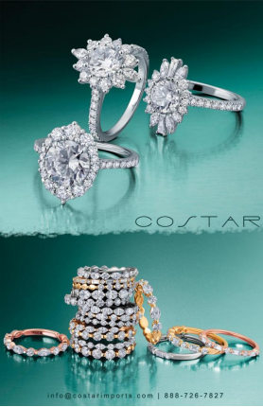

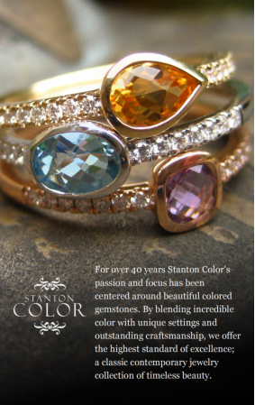
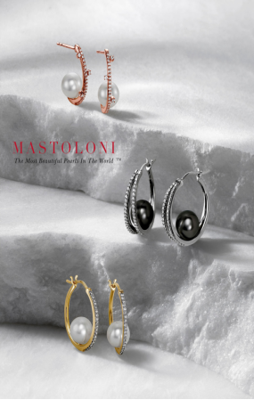

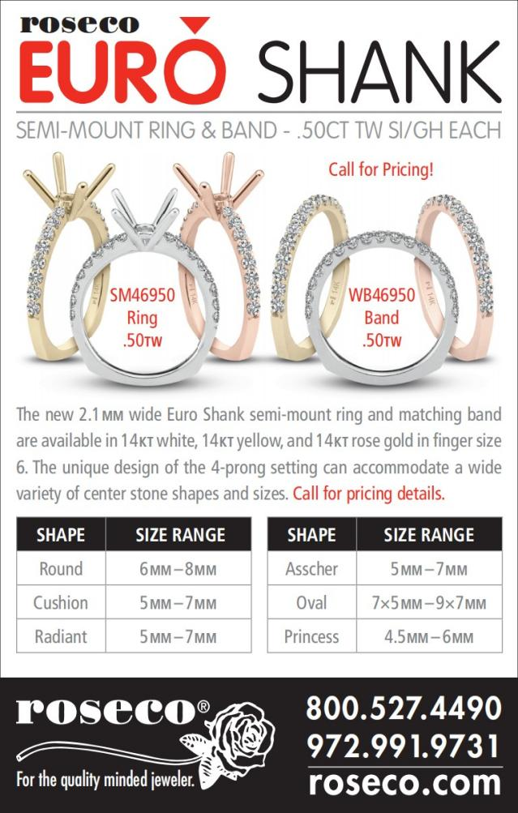

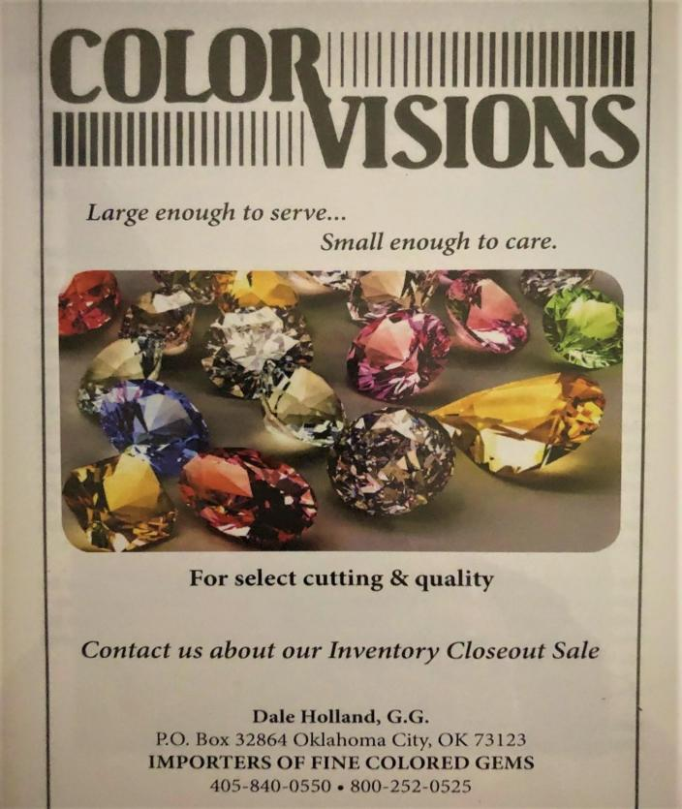

Oklahoma Jewelers Association 327 Chickasha Avenue
Chickasha, OK 73018-2673
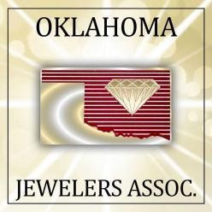
www.oklahomajewelers.org

In This Issue
Mark Your Calendar Presidents Message
JSA Latest Crime Report
5 Ways to Keep Your business Secure Retailer Spotlight: Ell’s Jewelry
Vendor Spotlight: Color Visions
Chantaburi, Thailand - World Gemstone Market
OJA Officers and Board of Directors
JA Report
Why Should I Join OJA Upcoming Events
OJA Sponsors

