MARK YOUR CALENDAR

OJA ANNUAL CONVENTION: GALA AND SEMINAR
SEPTEMEBER 18-19
OKLAHOMA CITY

There is no better time for Oklahoma jewelers to
‘come together’
for learning and socializing with fellow jewelers
and see the latest styles from premier vendors

- Saturday night Gala with premier vendors, dinner, and entertainment by Michael Murphy's Dueling Pianos!

- Sunday Seminar featuring guest speaker Jimmy DeGroot.

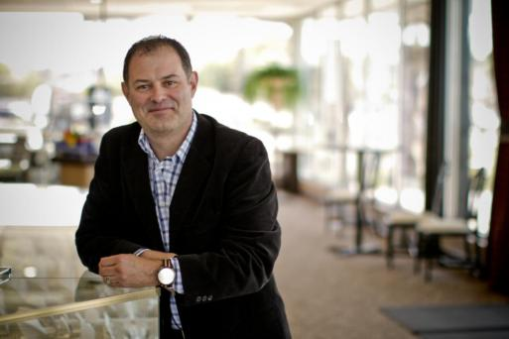

Jimmy's topic is “SPEAK THEIR LANGUAGE - How to talk with customers using THEIR language to close sales THEIR way.”

- New Location: The New Embassy Suites Northwest Hotel
located at NW Expressway and Independence in Oklahoma City

Watch your email and this summers newsletter for more detailed information
THE OKLAHOMA JEWELER
The Newsletter of the Oklahoma Jewelers Association

Volume 1 April 2021 Issue 30

MARK YOUR CALENDAR
OJA ANNUAL CONVENTION: GALA AND SEMINAR
SEPTEMBER 17-19
OKLAHOMA CITY
See Details on the Events page

Welcome to an “Oklahoma Strong” 2021
From your OJA Administrator, Lane Roberds

Jewelers have all just experienced a year unlike any other year, with jewelers dealing with the aftermath of the COVID , including illnesses and deaths, restrictions and shutdowns, and increased government control. The New Year brings hope and optimism that things will be better in 2021!
And remembering the phrase, “Oklahoma Strong.” Let’s take a moment to look back into OJA’s History. The Oklahoma Jewelers Association was founded in 1906 by men and women who came to a new land to build something where nothing had been before. Working together for a common cause they formed OJA, and throughout the years withstood many obstacles:
- 7 recessions (1907-08, 1917,1937, 1946-49, 1961-62, 1968-70, 2007-08)
- Panic of 1913
- Spanish Flu of 1918 (which in many ways mirrored our response to the China Virus)
- Crash of 1929
- Great Depression of 1929-33
- 1970’s high inflation
- 1980’s market crash of 1987 (recession lasting 21 months /20% interest rates)
- COVID Recession

Today's Oklahoma jewelers are indeed a rare breed of men and women, they too will work together, keeping OJA strong to overcome the obstacles ahead.
The OJA is strong and alive!! And clearly one of the most successful state jewelry associations in the country.
Covid brought a lot of challenges in 2020, but it can also open up a lot of opportunities

When OJA was founded, the strength of the organization was the “coming together” of its members to share and learn from each other, as well as from experts in our field. The same is true today today as we learn to operate our businesses in a new way, post COVID.

History Repeats Itself

It is said history repeats itself, and so it does. In the beginning, jewelers’ conventions consisted of jewelers “coming together” (you will hear that phrase frequently) and discussing the issues of concern at that time. At the 1910 OJA Convention, among the issues listed on the agenda for discussion were:
- How shall we fight the mail order evil?
- Honesty
- The jeweler and his usefulness to the community
Look at that list, and well over 100 years later we are still dealing with the issues of:
- Combating the internet
- Ethics
- Community Service

COVID has affected our industry in many ways. Jewelers were suddenly faced with problems and questions not faced before. They found themselves having to close, unsure when they could reopen, asking how do they do business while closed? They were quick to react and now they look both back and ahead.

- COVID isolationism drove more people to shop online, but it also created an opportunity for jewelers to find fresh new ways to promote their stores. And although online sales have increased in the last decade, they still represent a relatively small part of the jewelry sales market (11%).
- Consumers eager to “get out,” will still utilize the internet, but many still long for that “emotional exceptional experience” which comes from walking into a brick and motor, being happily greeted, and well cared for.
- Lou Holtz said “the key to success is to Do what is right, avoid what is wrong, and follow the golden rule.” In today’s “demanding” retail environment, doing right is always a winning strategy. And when you are known for that, your customers will be your strongest advocates.
- Today’s consumer wants to shop with companies that demonstrate a dedication to their community and the needs of that community. While it is sometimes appropriate to “do things quietly,” it is not a bad thing to let your customers know the good things your company does.

Despite the world being turned upside down last year, or maybe because of it, jewelry remains a special and emotional gift to give. In times of crisis people tend to understand what is important and cherish those who are most dear, and they may wish to symbolize those feelings with a special gift. We are fortunate to work in an industry where we can share in those special memories.

Your Thoughts?

We would love to hear your thoughts and insights as to the jewelry industry and possibly publish them in the OJA Newsletter. We have much to learn from one another, so please send your comments, ideas, or a suggested article to ojaoffice1906@gmail.com. Let us hear from you!

***************************************************************

9 Ways to Keep Your Jewelry Business Secure
By Sheri Ihde, Jewelers Mutual
Neglecting security measures early on could leave your business exposed during a time when crimes against jewelers tend to escalate. Plus, not getting in the habit of security best practices will only get more difficult to change as the year progresses. With jewelry store thefts increasing in recent years, here are nine ways to prevent crimes that can easily go unnoticed.
1) Prevent grab-and-run thefts. Only show one piece of jewelry at a time. Thieves posing as customers may try to make sales associates feel guilty for not letting them try more than one piece on to compare. If that happens, put something on yourself and compare side-by-side.
2) Document and share suspicious incidents. Create a running document or spreadsheet that can easily be searched and filtered by date, incident description, or any other variables you’re tracking. Reviewing your surveillance footage daily is less costly than an insurance deductible or replacing stolen merchandise. Whenever you encounter any suspicious activity tell your staff, crime prevention network, and local law enforcement. Be sure to report it immediately to the police and inform the Jewelers’ Security Alliance (JSA).
3) Open and close your business with two or more people. When opening the store, one associate should enter the premises while the other observes. The associate unlocking the facility should immediately lock the door after entering. Then, this individual should conduct a full walk-through of the premises, looking for anything suspicious. The other associate should watch from a safe distance with a cell phone ready to call police if the need arises. Only after receiving a pre-established “all-clear” notification from the first associate, the second associate may enter — again locking the door behind him/her — and assist with opening safes and/or vaults, setting up display cases, and preparing for the day’s business.
4) Meet and greet every customer that enters your business. Say hello to every customer who enters your store and make direct eye contact with them. Even if you’re busy with another guest, you should still go out of your way to offer a quick and friendly greeting. This immediate acknowledgment could be enough to tell any potential thief that your staff is alert and attentive, making your store a difficult target when it comes to crime. Also, keep your eye on groups of three or more customers entering your store. People rarely shop for jewelry in large groups and these individuals could be casing your store or working together to commit a distraction or sneak theft.
5) Make sure your showcases displaying valuable merchandise are strong enough to withstand a smash-and-grab robbery. Sophisticated criminals will case jewelry businesses to determine the easiest path for committing their crimes. They will know the layout of the building, where the most valuable merchandise is located, the exact value in each showcase, and even how much force is needed to break the showcase glass. By having a well-constructed showcase with resilient glass, you can limit — or even completely prevent — the loss of merchandise during a smash-and-grab robbery.
- Verify every alarm signal with your alarm monitoring facility. While safes and vaults are critical to limiting the amount of merchandise stolen in burglaries, criminals have proven time and again that, if given enough time, they can compromise the most durable of security equipment. That's why your alarm — and your relationship with your alarm system provider — is so valuable. Contact your alarm system provider to ensure that your alarm is providing the protection your business needs.
7) Require multiple forms of ID with check transactions, one being a photo ID. Compare signatures carefully from all forms of identification to ensure they match and keep a copy or write down the information.
8) Don't post photos that reveal the layout of your store or merchandise displays anywhere online. This includes social media as well as resources that your customers may use to find you such as Google My Business or Yelp.
9) Keep as much merchandise as possible in your safe or vault overnight. Sure, it’s more time consuming at the close and opening of business, however, you’re not fooling criminals by simply throwing a blanket over your showcases.
Looking for more loss prevention information? Visit the Jewelers Mutual Group Clarity Blog at https://www.jewelersmutual.com/clarity-blog.

PLATINUM SPONSORS OF THE OKLAHOMA JEWELERS ASSOCIATION

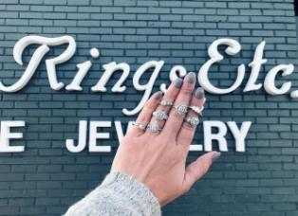

Retailer Spotlight:
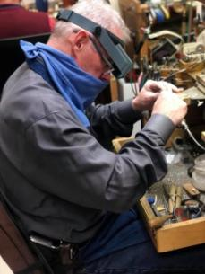
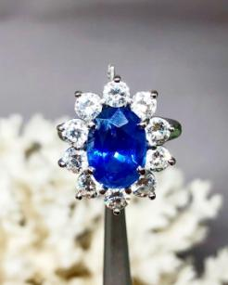
Trying to fit 40 years of our story into one segment is nearly impossible, but I can confidently say the sum of how we started and where we are now, we owe to Jesus with His favor and protection. Rings, Etc., is a childhood dream turned into an adult passion. In 1979, Roger Boulware was a high school kid with a passion for rocks, and for going buying coins from Jim Dunn at the Old Paris Flea Market. Jim hired Roger to sell coins, and eventually became his mentor. When Roger first saw Jim sell a ring, he realized he could make more money selling jewelry than coins, it ignited a passion for jewelry that soon matched his love for rocks. This led to self-teaching the art of hand carving and jewelry creation in his parents’ garage, and eventually to opening his own store, Rings, Etc.,
41 years of love and passion in our industry and for our customers -- this is truly our family’s ministry -- our personal space to bring love, happiness, and the light of Jesus to some of the most special days of their lives. And because we also purchase old wedding rings, we are also there for the sadder times. We each feel honored to be the hands and feet of Hope for each person who walks into our store.
“Why we joined OJA”. Roger and his Wife Norma attended the JCK show in Las Vegas in 2019 and on the plane ride home they sat next to Gen from Kelley’s Jewelers. Gen asked if Rings Etc. was a member of the OJA, and kindly explained all that OJA had to offer, including the people and the experiences. We signed up as soon as we got back, and when we attended our first OJA event, we met many others who made us feel very much at home. We knew then that we should have joined a long time ago. There is nothing like being in a room full of people who share your day-to-day issues and challenges. OJA is truly a place to feel at home.
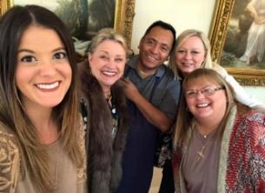
“I love being able to talk about how talented, gifted, selfless, and humble my dad is. He never ceases to amaze me and it’s truly a gift that I get be this alongside of him and learn every day. I love getting to listen and watch him share his testimony with so many, and getting to watch him humble himself as he shares the broken and hard road that led him to where he is at today. Nothing was ever handed to him – he is the hardest worker I know. I am so hopeful for what our community and what Rings, Etc., has in store for the years to come, with God in the driver’s seat. I feel blessed to work in a unique industry, and I love every minute of it. – Destiny Boulware
“Roger’s daughter Destiny is the store manager, having come to work for her dad after graduating from high school in 2011. She formed her own passion for jewelry, seeing her father’s talent and skill, and his relationships with customers. Destiny is now a certified Diamonds Graduate working towards her Graduate Gemologist certificate -- and planning to lead Rings Etc. into the next generation.”
Visit Our Website to learn more: www.ringsetcok.com
Vendor Spotlight: Mastoloni
On January 22nd we packed up our offices at 415 Madison Avenue, NY, and prepared to move 4 blocks away to our new home at 49 W 45th street. Anyone who has moved knows that it never goes seamlessly—the new offices were not ready for employees and multiple construction snafus kept popping up. All this, on top of a global pandemic, our kids’ schools closing (or going completely remote, and a less-than-stellar build-out was—frustrating.

Our story this year is the same as that of our fellow jewelers—overcoming a difficult pandemic and adapting to a new normal. Resilience is at the root of MASTOLONI—a tri-generational story about weathering trends, innovating designs, and building on an 85-year legacy of integrity and quality.

The company was founded 3 generations ago by Frank Mastoloni. His three sons: Frank, Raymond, and Edward joined the company in the 1960s. Each of their sons: Ray Jr., Fran, and Ed Jr. make up the current management team of the company. Influenced by its Italian roots, the company started dealing in gems, cameos, and pearls. Decades of travel around the world acquiring fine gems earned the company a worldwide reputation for discriminating taste, quality, and sophistication.

Today, Fran Mastoloni is one of the world’s foremost pearl experts, and spearheads pearl procurement. Ray Mastoloni, Jr., oversees production, sales, and marketing. Ed Mastoloni, Jr., handles fulfillment and IT. These core three are rounded out by production, sales, and marketing teams with decades of experience.

The company offers three product lines with the pearl as the focal point.
The Signature Collection is known for its South Sea strands, Specialty strands, Black Diamond jewelry, and unique, couture-level, 18k gold jewelry. Items of particular interest are our Eclisse Collection—luminous Tahitian pearls and striking rose gold—and the Dana series, luxe strands of black diamonds and multicolored Tahitian Pearls.

Sorrento features cultured pearls and 18k jewelry including rings, bracelets, necklaces, and earrings with pearls as the salient characteristic. Ask to see the fun rings and bracelets in yellow gold and the bridal sets in white gold.

Popular price-points and fashionable styling comprise the Gifts from the Sea. Hundreds of styles in 14k gold appeal to every demographic. Tin Cup necklaces and bracelets with lariat necklaces and big stud earrings are the volume pieces in this section of the line.

From traditional branding techniques including displays, signage, print advertising, and looped video, we have a visible and constantly evolving presence on social media including Facebook and Instagram. Our retailers can take advantage of our co-op program and branded display elements, as well as our expert representatives’ pearl education and training seminars.

As a proud member of The Plumb Club , we are excited to announce we are taking sales meetings on their Together platform. Please contact your sales representative, Chuck Zopfi, for more information. We look forward to “seeing” you soon.

Chuck Zopfi
Mastoloni Pearls
520-203-3777
chuck@mastoloni.com

Chuck Zopfi is a supporter of the Oklahoma Jewelers Association and serves on the Board of Directors.

Remembering Carter Buller

Carter Fay Buller, more affectionately known as PaPa Carter, was born on September 5th, 1945, and entered into heavenly eternal life on December 27th, 2020.

Carter was born in Goltry, Oklahoma, the son of Lynn and Mabel Eck Buller. While growing up, he attended Goltry Elementary School and graduated from Goltry High School. Carter continued his education by attending OSU Okmulgee to become a watchmaker and jeweler. After graduation from OSU Okmulgee in 1965, Carter moved to Ponca City, Oklahoma, to work for Spray’s Jewelry. Carter began purchasing Spray’s jewelry in 1974, and became the full owner of Spray’s Jewelry in 1993. He worked at Spray’s until the day he passed.

Carter was an loyal supporter of the Oklahoma Jewelers Association, having served on the Board of Directors since the 1980s and was President from 1994-1995.

Carter also served his country as a member of the Oklahoma National Guard.

**************************************************************************************
Oklahoma Jewelers Association
Officers &Board Members
2020-2021

Listed below are the Officers and Directors of the OJA, each one dedicated to making the Oklahoma Jewelers Association strong, productive, and beneficial for every jeweler in Oklahoma. They are here for you seeking to provide the best resources, education, vendors, and information to make your business as successful as possible. Please contact any member with questions or concerns you have about OJA or any business-related topic.

Jacoby Jarnagin
President
jaysjewelryinc@aol.com
(405) 224-9021

Gen Lisle
1st Vice President
gen@kellyjewelers.com
(580)772-3113

Kara Tipton-Smith
2nd Vice President
Kara.tipton@tiptonsfinejewelry.com
(580)-357-9472

Jason Jarnagin
Secretary/Treasurer
jaysjewelryinc@aol.com
(405) 224-9021

Mike Holmes
mholmes@bcclark.com
(405)232-8806

Coleman Clark
colemanclark@bcclark.com
(405) 232-8806
Ken Ellwanger
Gemguy1946@aol.com
(405) 273-7263

Ryan Jackson
Jacksonryan@gmail.com
(580) 237-5050

Annette Kinzie
leonardjewelry@gmail.com
(405) 372-3041

Sonda Jones
sonda@bcclark.com
(405) 755-4040

Lantz Smith
lantz@huntingtonfinejewelers.com
(405) 692-4300

London Smith
london@hfshawnee.dom
(405) 273-4300

Brent Buller
s.gifts@att.net
(580) 762-1604

Vicki Cunningham
vicki@cunninghamfinejewelry.com
(918) 627-7777

Jim Rice
jrice@moodysjewelry.com
(918) 749-4644

Mike Morrissey
mmorrissey@clockworkins.com
(504) 262-8239

Chuck Zopfi
chuck@mastoloni.com
(212) 757-7278

OJA ADMINISTRATORS

Lane Roberds
Ojaoffice1906@gmail.com
(405) 659-2281

Bob Carroll
Bob21@cox.net
(405) 820-3350

Website: www.oklahomajewelers.org

What Can We Do For You?
Why should I join OJA?

Jewelers ask . . . “Why should I join the Oklahoma Jewelers Association?” Have you asked yourself that question? Many have. If you ask any OJA member, they have a story to tell you - and we want to tell it.

Every newsletter we will feature a member who asked that very question, “Why should I join OJA”, discovered why they should, and did. We will ask, “Why did you join OJA”, and then tell their story in a feature article “Member Focus” Including - “Why I joined OJA”.

What about you? Have you asked yourself why you should join OJA? Let us count the ways that OJA is the association for Oklahoma’s independent retail jewelers - and why OJA is the association for you!

Professional Networking
Professionals in all phases of the jewelry industry agree that networking is an essential element of success - a key element to advance yourself and your business. The OJA is an exceptional resource for jewelers in every facet of the retail jewelers business to interact with their peers. Sales associates, bench jewelers, store owners and managers can expand and strengthen their resources through the functions of OJA. Among other benefits, an active membership in the association allows jewelers to open the doors to meet new industry professionals, learn new information and ideas, and accentuate their image as a professional jewelers.

Educational Programs
Knowledge is the proven road to success! The association’s seminars, workshops, and round table discussions allow jewelers to:
- Increase your knowledge and your standing as a professional jeweler.
- Broaden your understanding of a variety of industry topics
- Participate in workshops lead by nationally recognized industry presenters and trainers.
- Sit around tables with state and regional jewelers and discuss anything and everything that an independent jeweler might consider important or timely.

Activities: The OJA provides a social forum for its members to network and socialize. Often times the unplanned social events that are on every OJA meeting agenda are the innovative encounters that start the creative juices flowing and produce just the change you’ve been needing.

Membership Directory
The annual membership directory provides the names and contact information on all OJA member jewelers – and they are eager to offer options, alternatives and opinions. Have a question, a problem, or just need to talk shop with someone who understands the challenges of being an independent retail jeweler in the state of Oklahoma? The annual membership directory provides the names and contact information on all OJA member jewelers – and many are eager to offer options, alternatives, and opinions.

OJA’s Quarterly Newsletters: Read the association’s quarterly newsletter and be in the know about jewelry industry trends and activities in the state and the region. OJA encourages members to submit articles, information, opinions, advertisements, and items of interest for publication.

OJA is an Advocate: There is strength in numbers. Make your voice heard. The association is an advocate of members’ concerns. It provides members with security updates and a united voice with area law enforcement agencies. OJA is also a voice regarding legislation affecting the jewelry industry. OJA representatives have traveled to our state and nations capital to be a voice for Oklahoma jewelers on legislation that would affect Oklahoma Jewelers.

Join OJA today!

Industry Events

Below listed are the industry events as of this date

- JA New York August 8th - 10th
- Luxury / JCK Show Las Vegas August 24th - 30th
- Couture Las Vegas August 24th - 30th
- The Select Show Dallas September 12th - 13th
- OJA Convention (in person) September 17th - 19th (see details below)
- MJA Convention (in person) September 24th - 26th
- JA New York October 24th - 26th

***********************************************************************************

MARK YOUR CALENDAR

OJA ANNUAL CONVENTION: GALA AND SEMINAR
SEPTEMBER 17-19
OKLAHOMA CITY

There is no better time for Oklahoma jewelers to
‘come together’
for learning and socializing with fellow jewelers,
and see the latest styles from premier vendors

- Saturday night Gala with premier vendors, dinner, and entertainment by
The Dueling Pianos of Oklahoma City

- Sunday Seminar featuring guest speaker Jimmy DeGroot. Jimmy's topic is “SPEAK THEIR LANGUAGE - How to talk with customers using THEIR language to close sales THEIR way.”

- New Location: The New Embassy Suites Hotel located at NW Expressway and Independence (just off Hefner Parkway) in Oklahoma City

Watch your email and this summer’s newsletter for more detailed information

OJA PLATINUM SPONSORS

Jewelers Mutual Insurance Company

Clockwork Insurance Services, Inc.

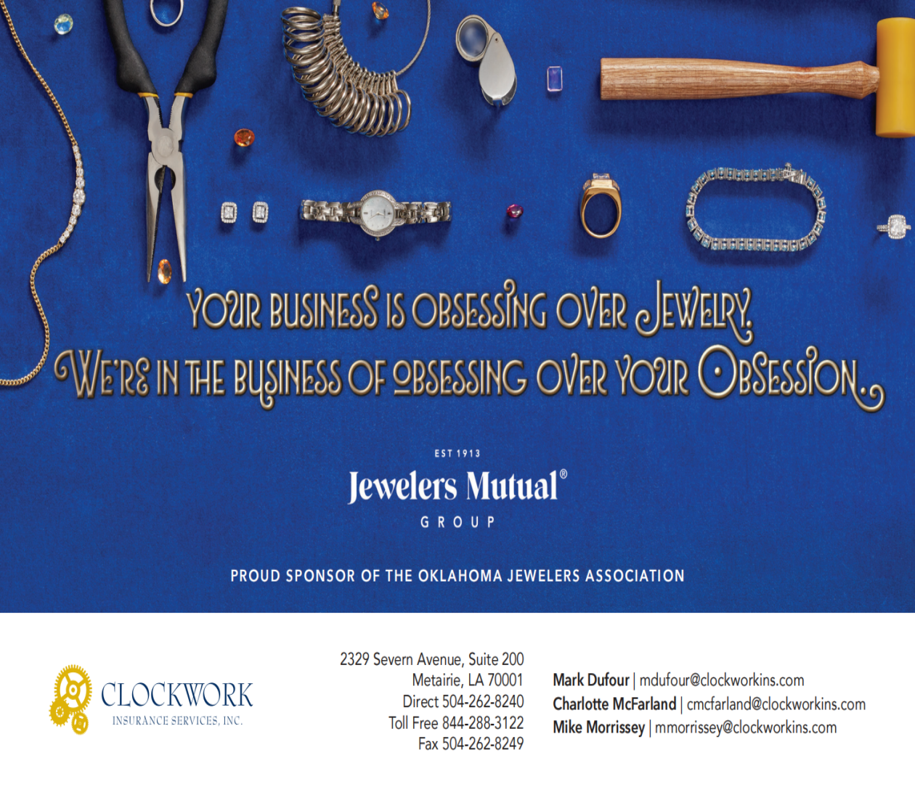

Our GOLD SPONSORS

Support these OJA Sponsors
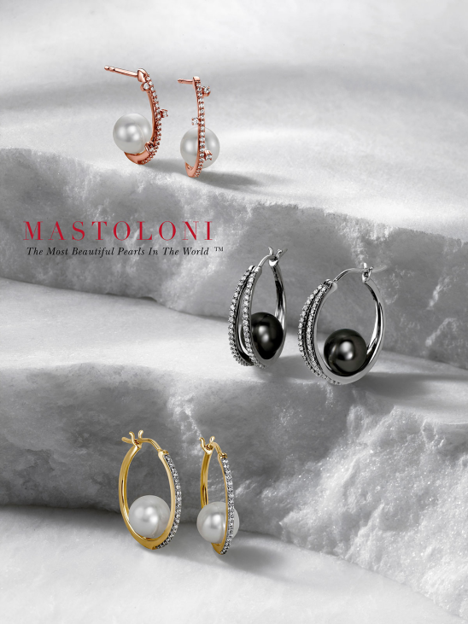

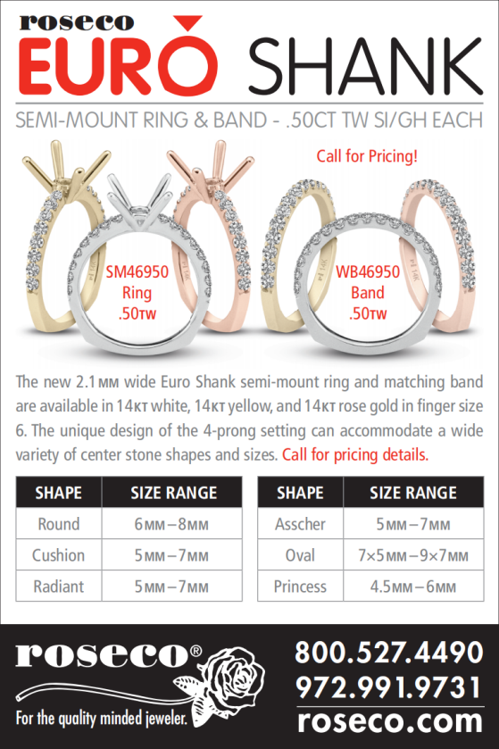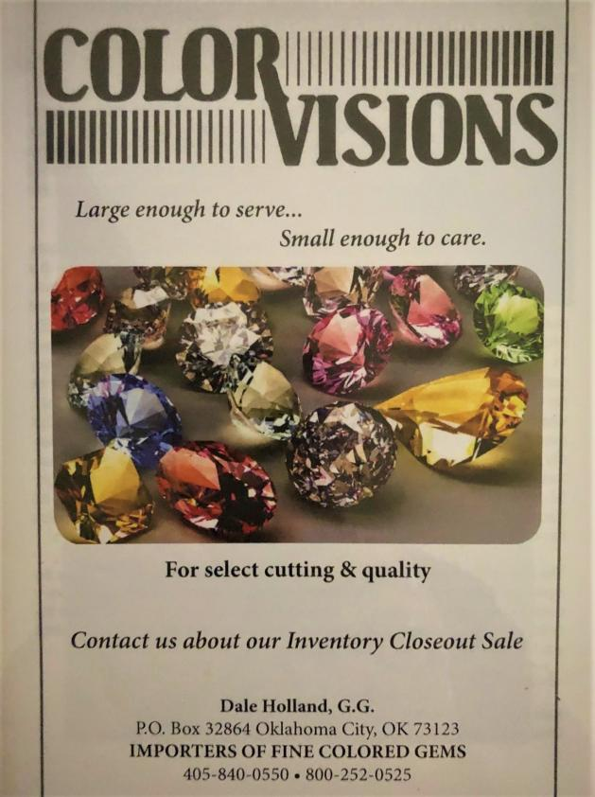

Oklahoma Jewelers Association
327 Chickasha Avenue
Chickasha, OK 73018-2673

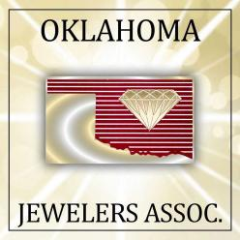
www.oklahomajewelers.org

______________________________________________

______________________________________________

______________________________________________

In This Issue
Welcome to Oklahoma Strong
Letter from Your OJA Administrators
9 Ways to Keep Your business Secure
Retailer Spotlight: Rings Etc.
Vendor Spotlight: Mastoloni
Remembering Carter Buller
OJA Officers and Board of Directors
Why Should I Join OJA
Upcoming Events
OJA Sponsors

