THE OKLAHOMA JEWELER

The Newsletter of the Oklahoma Jewelers Association

Volume 1 Merry Christmas Issue 32
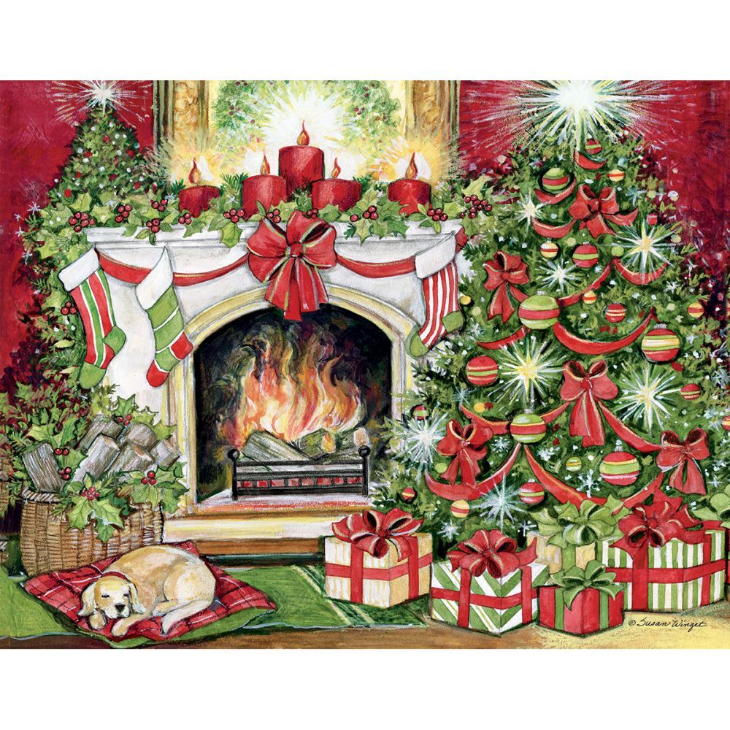
Wishing all OJA members, vendors, sponsors, and friends a wonderful holiday selling
Season, and a Happy of New Year.

2022 was a wonderful year for OJA, and 2023 promises to be even better. Join us in April for our Spring seminar, and September for our Annual Convention. Watch for our Spring Newsletter for more information. Our board listing is included in this newsletter, call on any board member if we can be of any assistance. We are eager to help!

Looking forward to seeing you in ‘23.

Gen
Gen Lisle
President
Oklahoma Jewelers Association

OJA ANNUAL CONVENTION: Oh What a Time !!!!!!

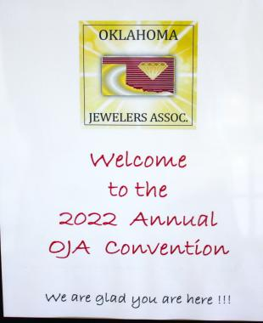
Oklahoma Jewelers gathered together in September for a wonderful time of fun, fellowship, good food, entertainment, and education.

Saturday night they were entertained by DJ LiTEBRite, had fun at the Photo Booth, caught up with old friends and made new ones. Sunday there were 5 speakers
(2 jewelry and 3 bench). Below are some highlight images of the weekend.

Truly one of the special things about the Oklahoma Jewelers Association is the bond between the members. We are not just individuals in the same profession - we are friends who like and care about each other and each others businesses.

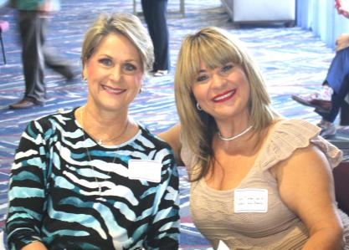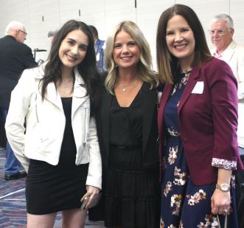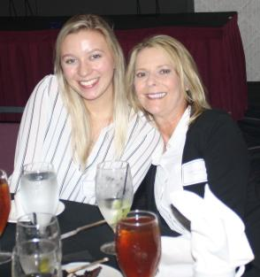

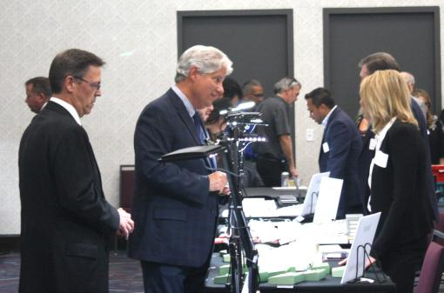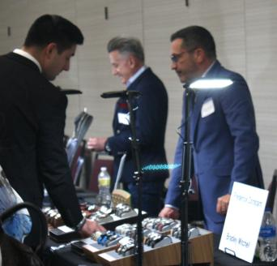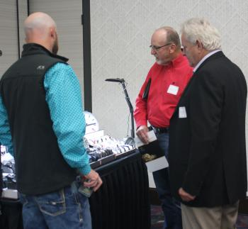

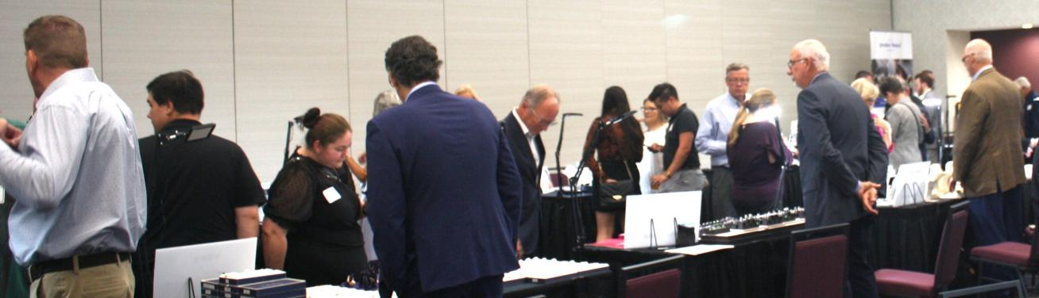

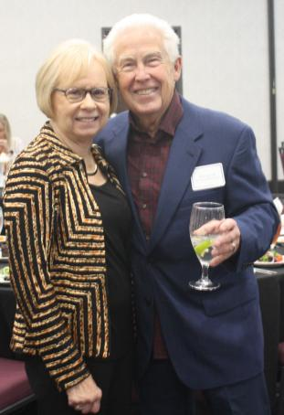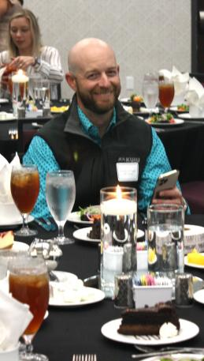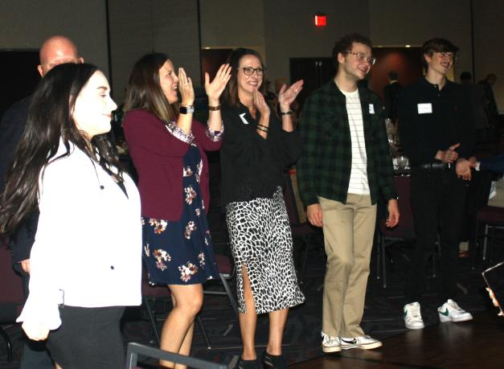

FUN AT THE OJA PHOTO BOOTH

One of the fun additions to this years Saturday Gala was the OJA Photo Booth.
It was a great opportunity for friends, families, and store staffs to have photos taken.

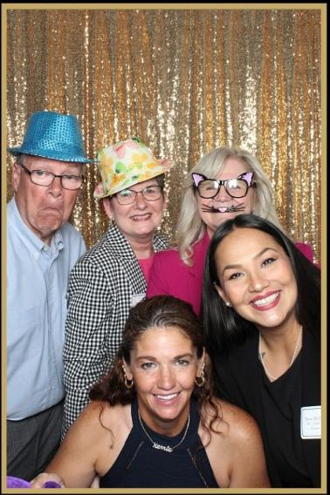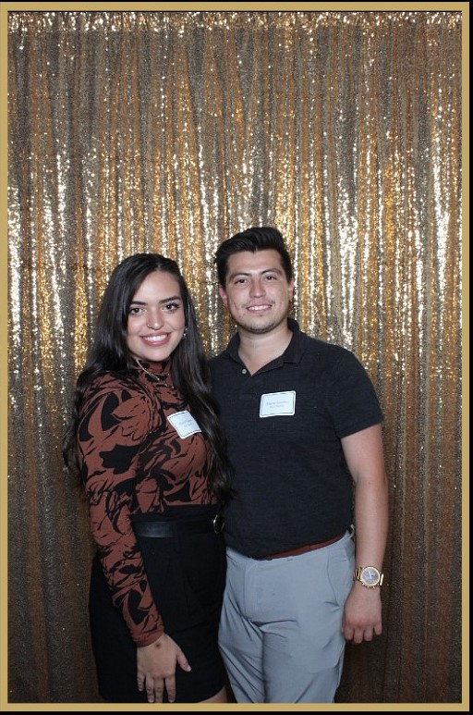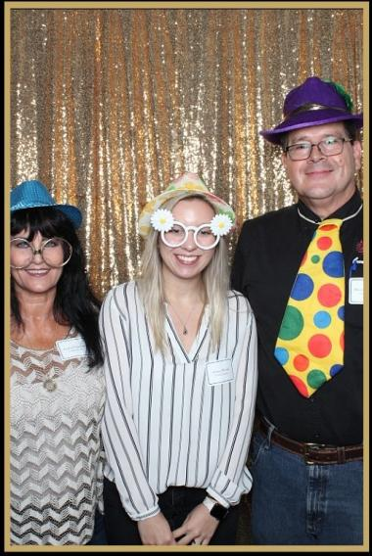

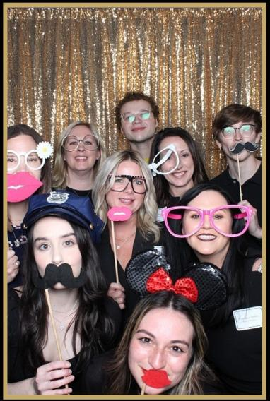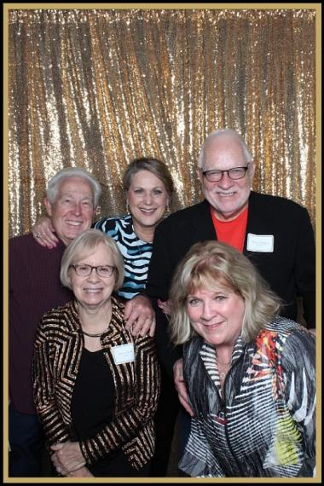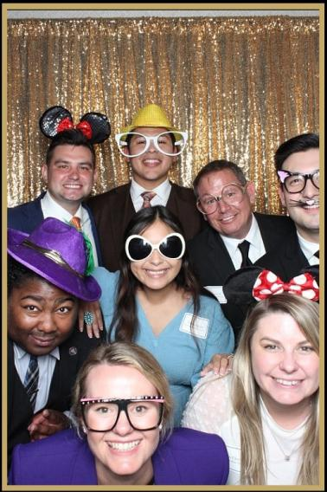

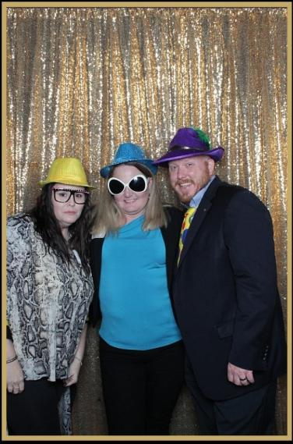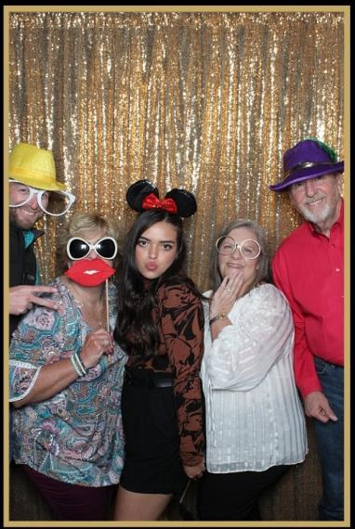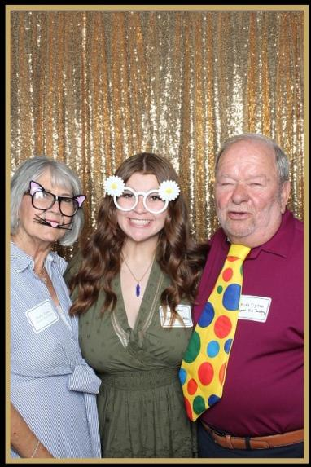

MORE FUN AT THE OJA PHOTO BOOTH

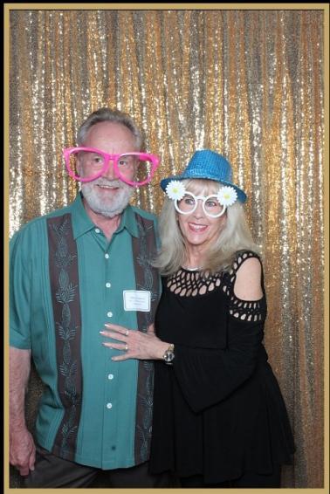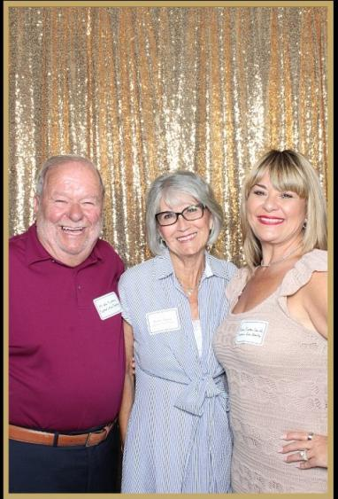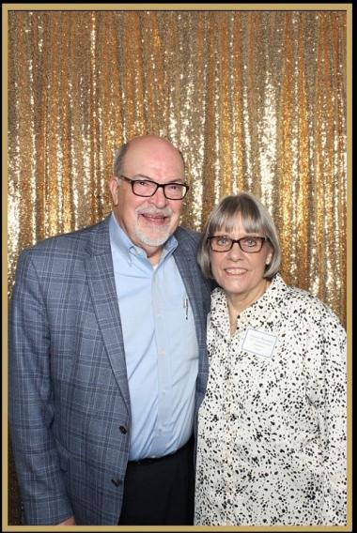

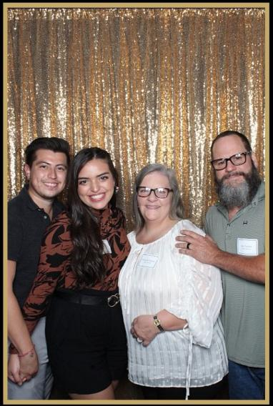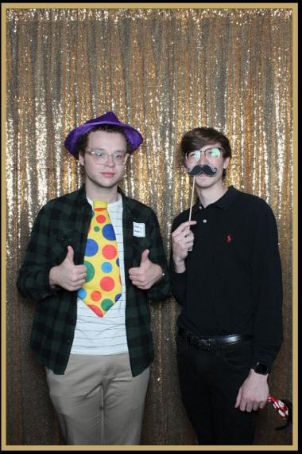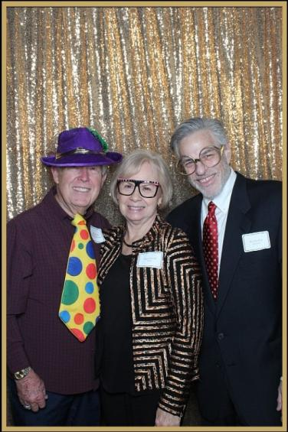

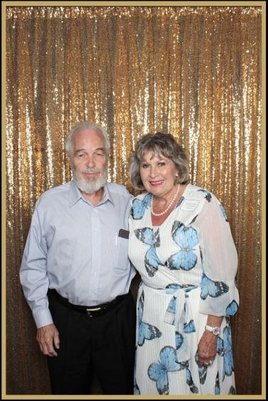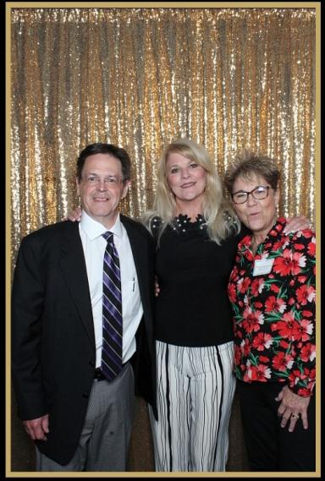

Everyone had a great time Saturday night. Wonderful time with Oklahoma Premier Vendors, good food, silent auction benefiting JFC, photo booth, and entertainment provided by DJ BRiTELiTE.

The Difference Between Priority Mail Express® and Express Mail®

By Logan Moore, Jewelers Mutual Group

USPS® Priority Mail Express® was previously known as Express Mail® until 2013 and nearly all the included services that existed before the name change remain, such as:
- Overnight to 2-day delivery
- Flat rate options
- Tracking
Fast forward to today and many jewelers are not aware of one crucial difference between Priority Mail Express and Express Mail: confirmation of signature.
USPS’s Signature Confirmation™ is now an add-on service, but the confusion doesn’t stop there.
It is included in the price of Priority Mail Express, but you still need to request it.
However, it is not included with other USPS shipping options and an additional fee applies when it is requested.

Because you’re shipping jewelry and not items of inconsequential value, you need to consider this service a must-have regardless of which service type you choose.
When you use JM™ Shipping Solution to ship and insure your packages, the system will automatically request Signature Confirmation with your purchase when using Priority Mail Express.
Whether you print your labels from an online source or go directly to a post office, here are a few more reasons for considering Signature Confirmation:
- Your insurance policy may require it
- It may help prevent delivery to the wrong address or person (the recipient must show an ID)
- Proof of a confirmed signature can help speed up the claims process if an item goes missing
Other Best Practices For Shipping Jewelry
Signature confirmation is just one way to keep your package safe. Knowing how to ship jewelry mistake-free means you also must follow these other basic guidelines:
- Plan your shipments ahead of time
- Disguise the shipping label
- Use two packages: a small box or padded envelop as the inner package and a slightly larger one as the outer package with labels on both
- Hand your package directly to your carrier and watch them scan it

One final security tip specific to Priority Mail Express: take caution when sending to specific postal codes.
For Example: In November 2019, Jewelers Mutual Group identified an abnormally high loss rate in New York’s Diamond District (postal codes 10017 and 10036). As a result, jewelers were advised to use different services for this particular area.
A Final Note
All carriers can experience situations like this, so remember that the opinions you read online from jewelers in every corner of the country may not be what’s best for you.
Do your own research and develop a system that offers simplicity and convenience, discounts and savings, and peace of mind. It doesn’t have to be confusing when programs are available to make your life easier.
Try JM Shipping Solution to compare options side-by-side, access pricing normally reserved for large enterprises, and save up to 50% of coverage costs when compared to jewelers block policies.

Sales of the World’s Most Precious Metal Continue to Soar

On track to achieve its 9th consecutive year of growth for platinum jewelry sales, PGI USA is predicting a white metal ‘wave’ in 2023.

For many in the jewelry industry, it will be a white Christmas. While Mother Nature may or may not cooperate, manufacturers and retailers alike are experiencing notably strong sales of platinum jewelry as they enter the final eight weeks of the selling season. A combination of a favorable metal price and consumer demand are resulting in double-digit growth for many companies.

When asked about the state of their platinum business, many manufacturing executives were quick to share their positive position on the metal:“Platinum offers two major advantages in the bridal category. First of all, at today’s metal market, consumers can truly afford the premier precious metal. Secondly, it allows jewelers to position themselves as providing top quality along with superior service and trust, thereby maximizing the lifetime value of that client. Closing the gap between consumers’ preferences and consumers’ final purchases is always a big growth opportunity.

“Across our portfolio of jewelry brands, from ArtCarved engagement rings to Goldman wedding and anniversary bands, we’re posting year over year double-digit growth and anticipate that trend continuing through 2023.” – Jonathan Goldman, CEO, Frederick Goldman, Inc.

“A.JAFFE has been creating platinum bridal jewelry since its inception in 1892. Platinum has always elevated our brand and even more so during the last two year as brides are demanding diamonds of the highest quality set in the most prestigious metal”. – Sam Samberg, Chairman, A.JAFFE.

When asked, retail executives were equally as bullish on platinum:
“Platinum holds a high status in the fine jewelry industry, notably so at Robbins Brothers, resulting in an increase in overall value for our business throughout the years. We continue to see year-over-year double digit increases in our platinum sales, with strong interest from our guests as this remains a high priority and focus for Robbins Brothers.” – Sue Hopeman, Vice President of Merchandising, Robbins Brothers

This year, PGI USA enacted various industry-focused programs, including annual business grants and strategic partnerships, to support manufacturers, brands, designers, and retailers to continue to prioritize platinum and grow that sector of their businesses. 2023 will see an increase in programming and an opportunity to establish new partnerships with the next class of grant recipients, all working towards a goal of promoting the power of platinum. For more information, please visit www.platinumjewelry.com
Article reprinted with permission of The Plumb Club.

History of Where To Buy Watches
GREAT PIECE OF HISTORY...
If you were in the market for a watch in 1880, would you know where to get one? You would go to a store, right? Well, of course, you could do that, but if you wanted one that was cheaper and a bit better than most of the store watches, you went to the train station!

Sound a bit funny?

Well, for about 500 towns across the northern United States, that's where the best watches were found. Why? The railroad company wasn't selling the watches, not at all. The telegraph operator was.

Most of the time the telegraph operator was located in the railroad station because the telegraph lines followed the railroad tracks from town to town. It was usually the shortest distance and the right-of-way had already been secured for the rail line.

Most of the station agents were also skilled telegraph operators and it was the primary way they communicated with the railroad. They would know when trains left the previous station and when they were due at their next station. And it was the telegraph operator who had the watches.

As a matter of fact, they sold more of them than almost all the stores combined for a period of about 9 years. This was all arranged by "Richard", who was a telegraph operator himself.

He was on duty in the North Redwood, Minnesota train station one day when a load of watches arrived from the East. It was a huge crate of pocket watches. No one ever came to claim them. So Richard sent a telegram to the manufacturer and asked them what they wanted to do with the watches. The manufacturer didn't want to pay the freight back, so they wired Richard to see if he could sell them. So Richard did.

He sent a wire to every agent in the system asking them if they wanted a cheap, but good, pocket watch. He sold the entire case in less than two days and at a handsome profit.

That started it all. He ordered more watches from the watch company and encouraged the telegraph operators to set up a display case in the station offering high quality watches for a cheap price to all the travelers. It worked!

It didn't take long for the word to spread and, before long, people other than travelers came to the train station to buy watches. Richard became so busy that he had to hire a professional watchmaker to help him with the orders. That was Alvah. And the rest is history as they say.

The business took off and soon expanded to many other lines of dry goods. Richard and Alvah left the train station and moved their company to Chicago.

YES, IT'S A LITTLE KNOWN FACT that for a while in the 1880s, the biggest watch retailer in the country was at the train station. It all started with a telegraph operator: Richard Sears and partner Alvah Roebuck!

Now that's History.

OJA GOLD Sponsors

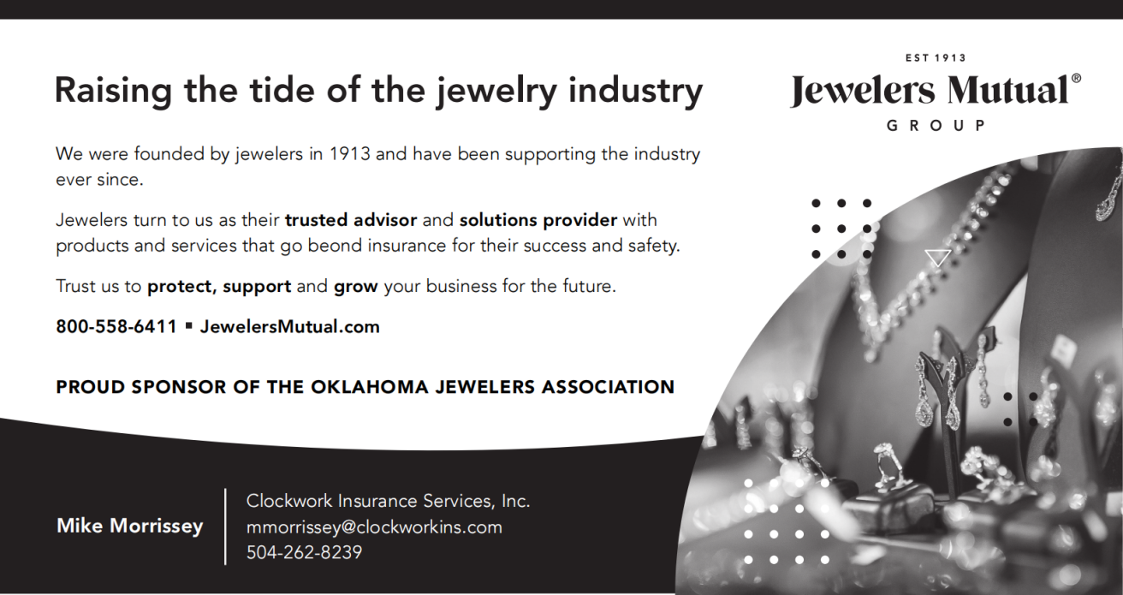

Support These OJA Vendor Sponsors

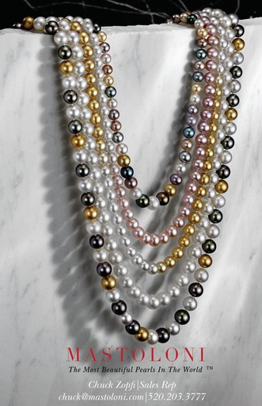

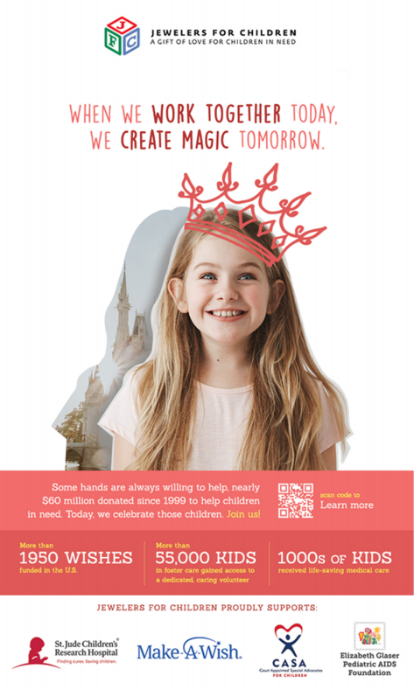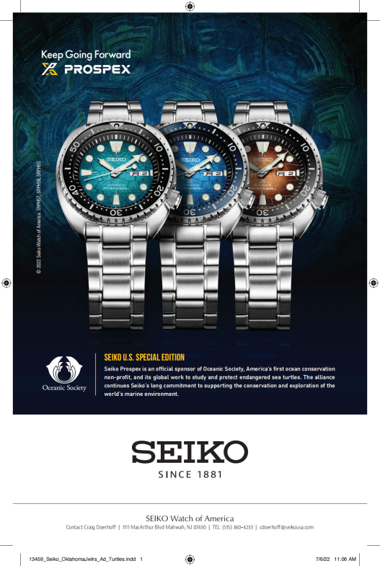

Support These OJA Vendor Sponsors

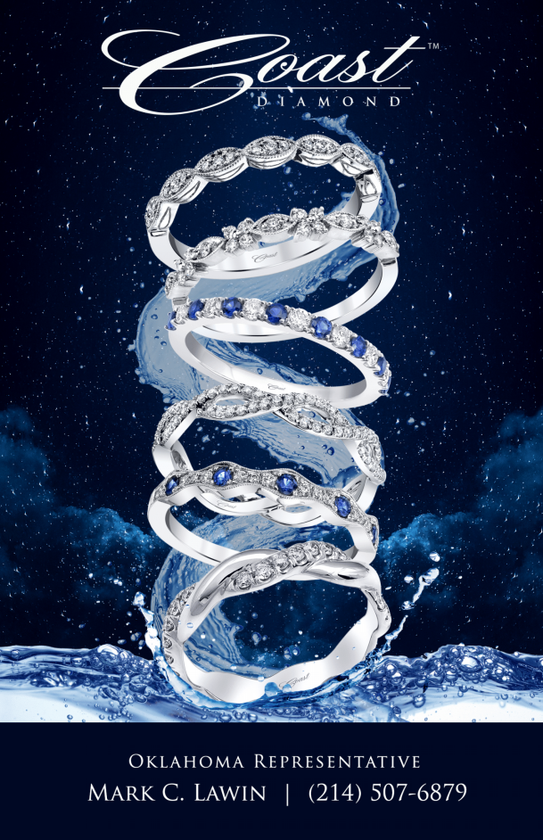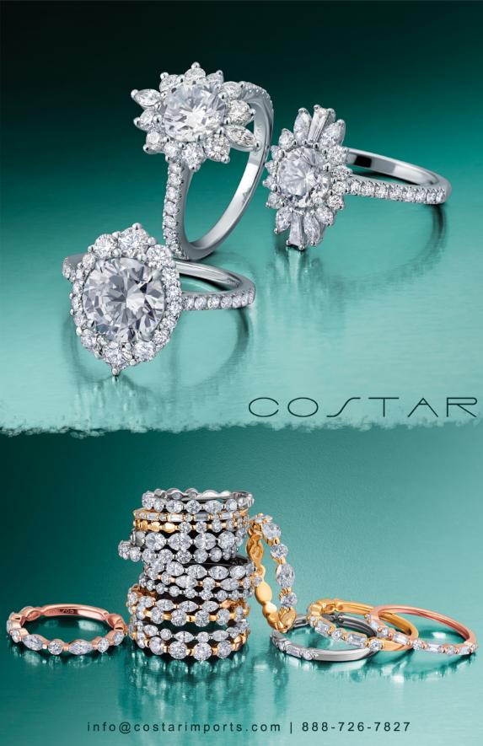

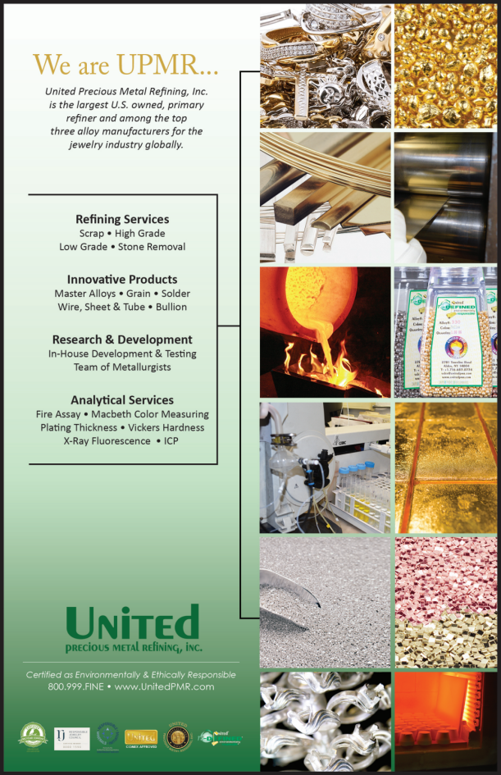

Support These OJA Vendor Sponsors

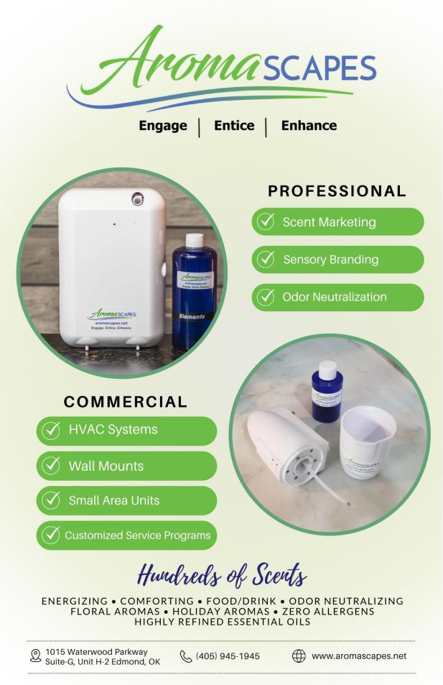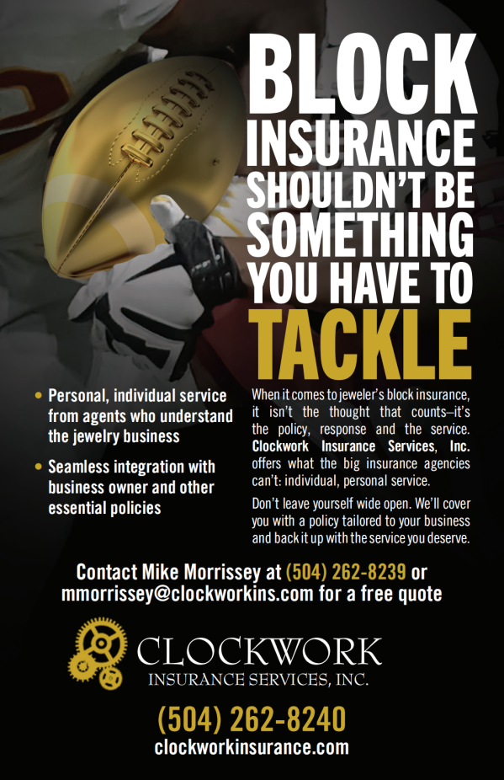

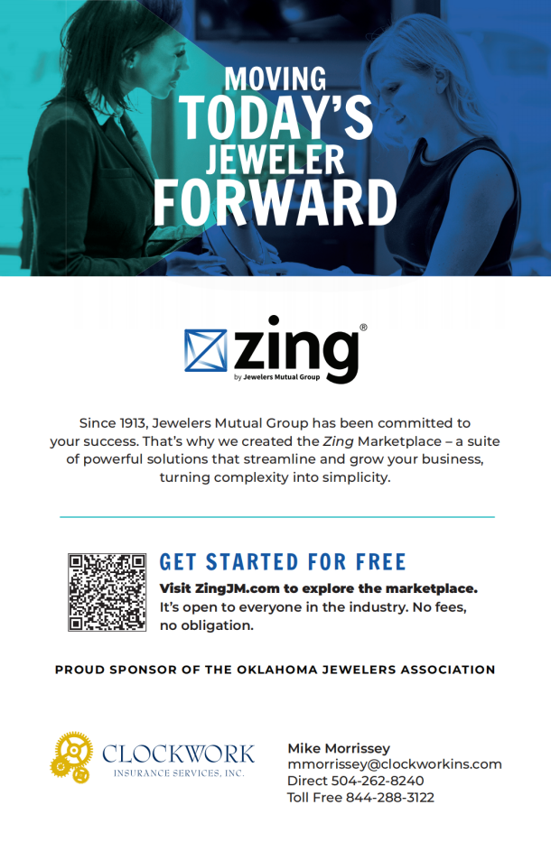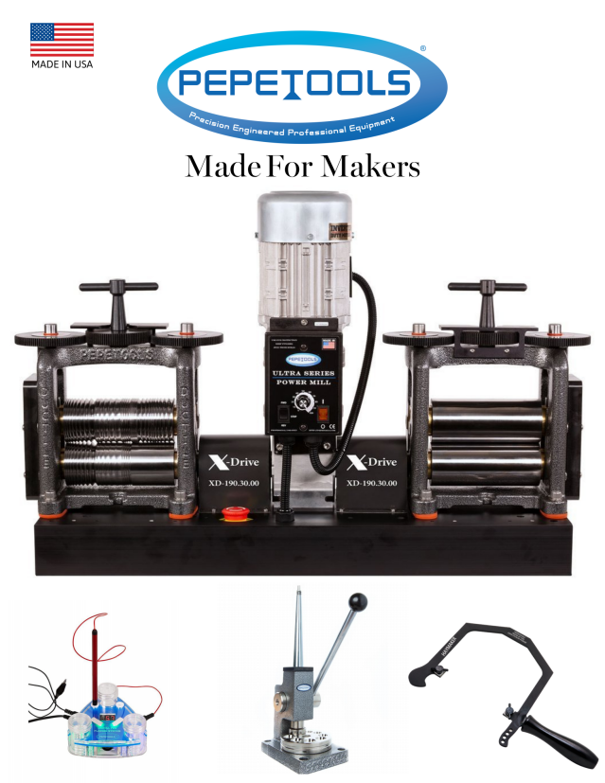

OJA Officers and DIRECTORS 2023

Gen Lisle— President
Kelley Jewelers
Weatherford, OK 73096-0689
Phone: 580-772-3113
email: gen@kelleyjewelers.com

Kara Tipton - Smith - First Vice President Ryan Jackson - 2nd Vice President
Tipton’s Jewelry Jackson Diamond Jewelers, Inc.
Lawton, OK 73505 Enid, OK. 73701-4006
Phone 580-357-9472 Phone: 580-237-5050
email: kara.tipton@tiptonsfinejewelry.com Email: jacksonryan@gmail.com

Jason Jarnagin - Treasurer Jacoby Jarnagin - Past President
Jay’s Jewelry Jay’s Jewelry
Chickasha, OK. 73018-2673 Chickasha, OK. 73018-2673
Phone 405-224-9021 Phone 405-224-9021
Email: jaysjewelryinc@aol.com Email: jaysjewelryinc@aol.com

Coleman Clark ASSOCIATE DIRECTORS
B. C. Clark Jewelers - Downtown
Oklahoma City, OK. 73102 Mike Morrissey
Phone: 405-232-8806 Clockwork Insurance Services, Inc.
Email: colemanclark@bcclark.com Neenah, WI., 54956
Phone: 504-262-8239
Lexis Parker Email: mmorrissey@clockworkins.com
Huntington Fine Jewelers
Shawnee, OK. 74804 Chuck Zopfi
Phone: 405-273-4300 Frank Mastoloni & Sons
Email: Lexis@huntingtonfinejewelers.com New York, NY., 10017
Phone: 212-757-7278 ext. 129
London Smith Email: chuck@mastoloni.com
Huntington Fine Jewelers
Midwest City, OK. 73110
Phone: 405-832-4300
Email: London@huntingtonfinejewelers.com

Lauren Clawson
Huntington Fine Jewelers
Oklahoma City, OK. 73170
Phone: 405-692-4300
Email: lauren@huntingtonfinejewelers.com

EXECUTIVE DIRECTOR

Lane Roberds
Cell: 405-659-2281
Email: ojaoffice1906@gmail.com

Why Should I Join OJA?

Jewelers ask . . . “Why should I join the Oklahoma Jewelers Association?” Have you asked yourself that question? If you ask any OJA member, he or she may have a story to tell you. Every newsletter will feature a member who has asked that very question, “Why should I join my trade association?” Look for their interesting answers in future issues.

Professional Networking
Professionals in all phases of the jewelry industry agree that networking is an essential element of success -- a key element to advance yourself and your business. The OJA provides exceptional opportunities for jewelers in every facet of the jewelry business to interact with peers. Sales associates, bench jewelers, store owners, and managers can expand and strengthen their resources through the functions of OJA. Among other benefits, an active membership in the association opens the doors to meet new industry professionals, gain new information and ideas, and accentuate their images as professional jewelers.

Educational Programs
Knowledge is the proven road to success! The association’s seminars, workshops and round table discussions allow jewelers to:
  - Increase your knowledge and your standing as a professional jeweler.
  - Broaden your understanding of a variety of industry topics
  - Participate in workshops lead by nationally recognized industry presenters and trainers.
  - Sit around tables with fellow jewelers and discuss anything and everything that an independent jeweler might consider important or timely.

Activities: The OJA provides a social forum for its members to network and socialize. Often, it is the unstructured social events that are on every OJA meeting agenda which become the innovative encounters that start the creative juices flowing and produce just the change you’ve been needing.

Membership Directory
The annual membership directory provides the names and contact information on all OJA member jewelers – and they are eager to offer options, alternatives, and opinions. Have a question, a problem, or just need to talk shop with someone who understands the challenges of being an independent jeweler in Oklahoma? The annual membership directory provides the names and contact information of all OJA member jewelers – a ready and often helpful resource.

OJA’s Quarterly Newsletters: Read the association’s quarterly newsletter and be in the know about industry trends and activities in the state and the region. OJA encourages members to submit articles, information, opinions, advertisements, and items of interest for publication.

OJA is an Advocate: There is strength in numbers. Make your voice heard. The association provides members with security updates and can present a united voice with area law enforcement agencies. OJA is also a voice regarding legislation affecting the jewelry industry; Legislators listen when OJA Speaks! – because we are the voice or more than 100 of their constituents

Join OJA Today

2023 Jewelry Shows

January 28 - February 01 Centurion Jewelry Show
January 31 - February 05 AGTA Gem Fair

March 12 - 13 JA New York Spring Show

April 16 OJA Spring Seminar (Embassy Suites South Meridian OKC)
May 01 - 03 AGS Conclave

June 01 - 04 Couture
June 01 - 06 JCK Luxury
June 01 - 04 Las Vegas Antique Jewelry & Watch Fair
June 02 - 05 JCK

August 12 The INSTORE Show

September 10 - 11 Select Jewelry Show Dallas

September 16 - 17 OJA Annual Convention (Embassy Suites NW OKC)
October 06 - 08 Missouri Jewelers Association Annual Convention
October 29 - 31 JA New York Fall Show

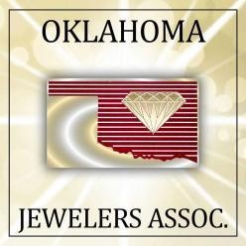
Oklahoma Jewelers Association
327 Chickasha Avenue
Chickasha, OK 73018

ojaoffice1906@gmail.com

www.Oklahomajewelers.org

